A-PAG AI Architecture

1. Ingestion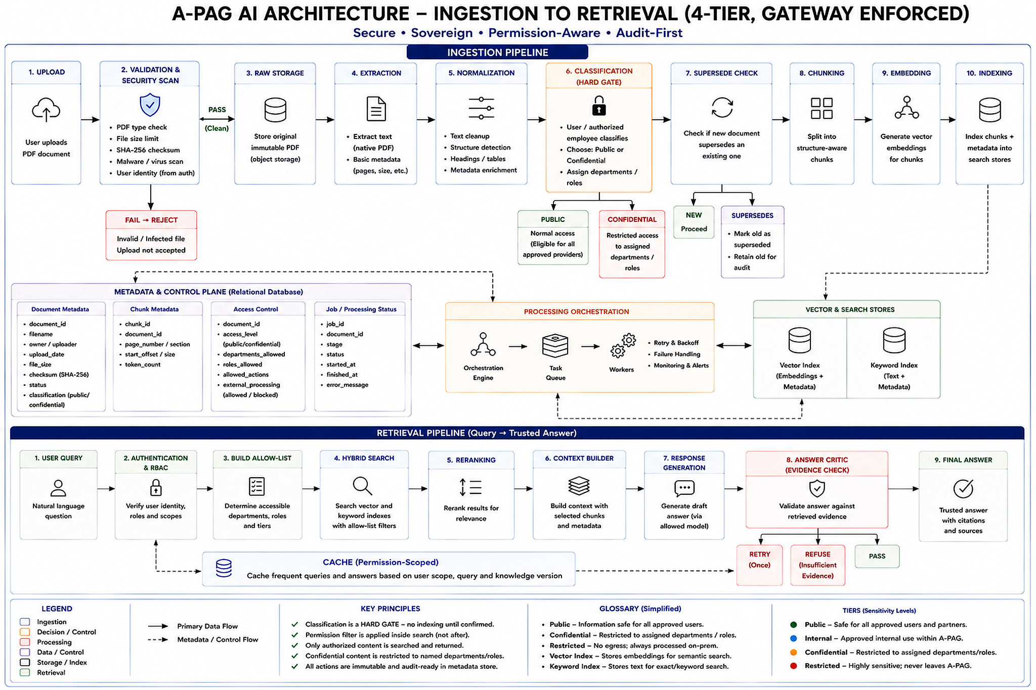
1. Upload
User uploads a PDF.
2. Validation & Security Scan
Check PDF type, file size, checksum, malware and user identity. Invalid files are rejected.
3. Raw Storage
Store the original PDF unchanged for audit and reprocessing.
4. Extraction
Extract text, metadata, tables and use OCR only where required.
5. Normalization
Clean text, detect structure, headings, tables and add page/section metadata.
6. Classification Gate
Authorized user classifies the document as Public or Confidential. The document cannot proceed until classification is confirmed.
7. Supersede Check
Check whether the document replaces an older version. Old versions remain for audit but are excluded from normal retrieval.
8. Chunking
Split the document into structure-aware chunks while keeping page and document metadata.
9. Embedding
Convert chunks into vectors for semantic search.
10. Indexing
Store chunks in:
- Vector index → semantic search
- Keyword index → exact keyword search

2. Control Plane
PostgreSQL stores:
- Document metadata
- Chunk metadata
- Access permissions
- Processing/job status
- Audit information
A queue and workers handle heavy tasks such as extraction, OCR, embedding and indexing.

3. Retrieval
1. User Query
User asks a natural-language question.
2. Authentication & RBAC
Identify the user and their role/department.
3. Build Allow-List
Determine which documents the user is allowed to access.
4. Hybrid Search
Search the vector and keyword indexes using the user's permissions as filters.
5. Reranking
Rank the retrieved chunks by relevance.
6. Context Builder
Prepare the best permitted chunks and metadata for the LLM.
7. Response Generation
LLM generates a draft answer from the retrieved evidence.
8. Answer Critic
Check whether the answer is supported by the retrieved evidence.
- Pass → final answer
- Fail → retry once
- Still unsupported → refuse
9. Final Answer
Return the trusted answer with source/citation information.

Overall
PDF
↓
Validate → Extract → Normalize → Classify
↓
Supersede → Chunk → Embed → Index
↓
User Query
↓
Authenticate → Permission Filter
↓
Hybrid Search → Rerank → Context
↓
LLM → Answer Critic
↓
Trusted Answer + Citation

Backend API: FastAPI
Task Queue: Celery + Redis (or Temporal)
Relational & Auth: PostgreSQL (Schemas, RBAC, Audit Log)
Vector DB: Qdrant
PDF & Text Parsing: PyMuPDF/ unstructured.io
Embeddings: bge-m3
Reranker: bge-reranker-large
LLM Engine: vLLM / Sarvam / Ollama
Guardrails: sqlglot (for SQL), Instructor / Pydantic (for Critic schema validation)

